**21.DFA using a simulator to accept even number of a’s.**

**AIM:** Todesign DFA using a simulator to accept even number of a’s.

**TRANSITION DIAGRAM:**

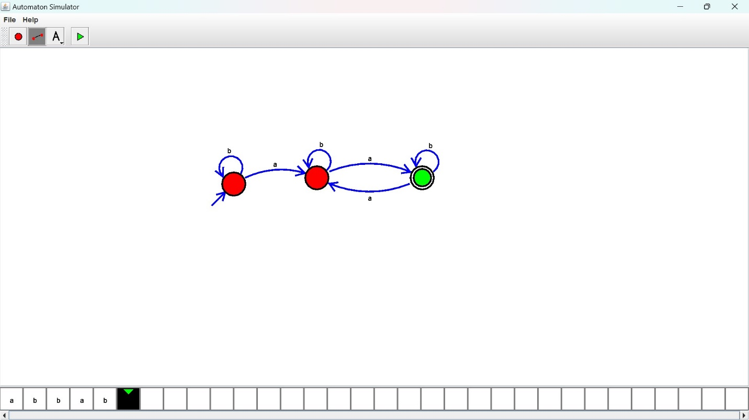

**RESULT:** Hence designed DFA using a simulator to accept the even number of a’s by using a simulator.